tCentric Hybrid™
Synchro Glide – Upholstered Backrest* |  | Midnight Black [t-MBUP-SG]
 |  | Light Grey [t-LGUP-SGG]
Backrest:  Midnight Black / Light Grey  - Front upholstered dual curve backrest  - 5" Patented Back Height Adjustment System  - Solid Back Cap  - tCentric Lumbar Support with Air Lumbar (pump)  Arms:  Midnight Black / Light Grey [G]  Options:  - tCentric Armrest Height & Lateral [TCL / TCLG]  - tCentric Armrest Height & Swivel [TC360 / TC360G]  - tCentric Armrest Height, Lateral & Swivel [TCL360 / TCL360G]  Seat:  Midnight Black / Light Grey  - Dual Density Molded Polyurethane Foam  - Eight ply hardwood seat structure  - Tailored upholstery on seat pan (20”w x 19”d)  Options:  - Extra Small Seat (17 ½”w x 15 ½”d) [XSS]  - Small Seat (18 ½”w x 17”d) [SS]  - Plus Size Seat (22”w x 19”d) [PS]  - Extra Long Seat (20”w x 21”d) [XLS]  - Extra Deep Seat (22”w x 21”d) [XPS]  - Energy Absorbent Memory Foam [EA]  - Triple Density Foam (adds ¼” to seat width & depth) [TDF]  - Non-tailored Seat Pan [NTS]  Synchro Glide Mechanism:  Midnight Black / Light Grey  - Seat Tilt Lock Out  - Free Float  - Independent Back Angle Adjustment  - Synchro 2:1 Ratio  - Adjustable Spring Tension  - 2 ½” Depth Adjustable Seat Slider | Pneumatic Lift (Seat Height):  Midnight Black / Light Grey  - 125 mmLT Pneumatic Lift (17 ½" – 22 ¼")  Options:  Midnight Black / Light Grey [G]  - 70 mm Pneumatic Lift (17” - 19 ¾”) [70MM/G70MM]  - 80 mm Pneumatic Lift (17 ¾”-20 ¾”) [80MM/G80MM]  - 100 mm Pneumatic Lift (18 ½”-22”) [100MM/G100MM]  - 140 mm Pneumatic Lift (19 ½”-25”) [140MM/G140MM]  Chrome  - 100 mm Chrome Pneumatic Lift (18 ½”-22”) [100MMCH]  - 125 mm Chrome Pneumatic Lift (18 ½”-23 ¼”) [125MMCH]  - 140 mm Chrome Pneumatic Lift (19 ½”-25”) [140MMCH]  Base/Glides/Casters:  Midnight Black / Light Grey  - 26" Glass Reinforced Nylon Mid Profile Base  - 5 Dual Wheel Nylon Casters 2  Options:  - Chrome Accent Casters [CAC]  - 26” Polished Aluminum Base [PMB]  - Dual Wheel Urethane Caster 2 [UC2]  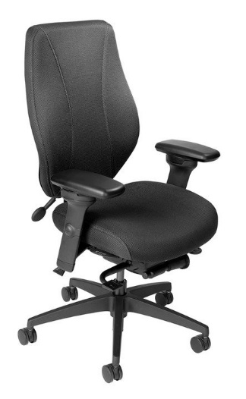  Additional Options:  Midnight Black / Light Grey [G]  - Adjustable Headrest [AHR / AHRG]  Measurements/Overall Dimensions:  - Boxed Weight/Size: 56 lbs. / 11.7 cu.ft.  *Mixing of Midnight Black & Light Grey components is not an option.

