tCentric Hybrid™
All Mesh – Knee Tilt* | Midnight Black [t-MBMESH-KT]
Backrest:  - 5" Patented Back Height Adjustment System  - Dual Curve Mesh Backrest (19"w x 25"h)  Arms:  Midnight Black  Options:  - tCentric Armrest Height & Lateral [TCL]  - tCentric Armrest Height & Swivel [TC360]  - tCentric Armrest Height, Lateral & Swivel [TCL360]  Seat:  Midnight Black  - Airless Cushion Technology  - Mesh Seat with 30% Glass Filled Nylon Frame (21”w x 18 ½”d)  Options:  Midnight Black [MB]  - Small Mesh Seat (20”w x 16 ½”d) [TMBMSS]  - Extra Long Mesh Seat (21”w x 20 ½”d) [TMBMXLS]  Knee Tilt Mechanism:  Midnight Black  - 5” Incremental Back Height  - Infinite Lock Free Float  - Back Angle  - Spring Tension  - 2 ½” Seat Depth  - Pneumatic Seat Height  Pneumatic Lift (Seat Height):  Midnight Black  - 125 mmLT Pneumatic Lift (18 ¾" – 23 ½")  Options:  Midnight Black / Light Grey [G]  - 70 mm Pneumatic Lift (18 ¼” – 21”) [70MM]  - 80 mm Pneumatic Lift (19”-22”) [80MM]  - 100 mm Pneumatic Lift (19 ½”-23 ¼”) [100MM]  - 140 mm Pneumatic Lift (20 ¾”-26 ¼”) [140MM]  Chrome  - 100 mm Chrome Pneumatic Lift (19 ½”-23 ¼”) [100MMCH]  - 125 mm Chrome Pneumatic Lift (19 ¾”-24 ½”) [125MMCH]  - 140 mm Chrome Pneumatic Lift (20 ¾”-26 ¼”) [140MMCH] | Base/Glides/Casters:  Midnight Black  - 26" Glass Reinforced Nylon Mid-Profile Base  - 5 Dual Wheel Nylon Casters 2  Options:  - Chrome Accent Casters [CAC]  - 26” Polished Aluminum Mid-Profile Base [PMB]  - Dual Wheel Urethane Caster 2 [UC2]  Additional Options:  Midnight Black  - tCentric Lumbar Support [TLS]  - tCentric Lumbar Support with Air Lumbar (pump) [TLSAL]  - Adjustable Headrest [AHR]  Measurements/Overall Dimensions:  - Boxed Weight/Size: 46.4 lbs. / 11.7 cu.ft.  Mesh Material:  Both the tCentric Hybrid seat and backrest are made from elastomeric mesh with fill yarns made from polyester.  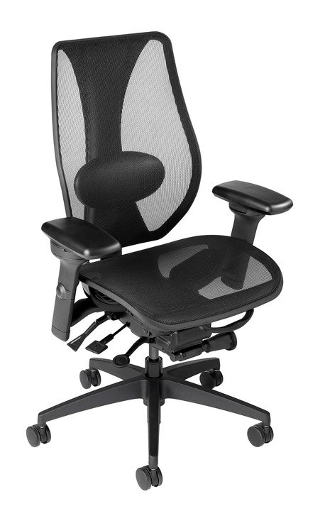  When stretched, this material yields excellent load-bearing properties and resiliency, showing less than 5% load-bearing loss when tested according to BIFMA standards.  To clean use mild household or hospital detergents.

