tCentric Hybrid™
All Mesh – Controlled Motion | Midnight Black [t-MBMESH-CM]
 | Light Grey [t-LGMESH-CMG]
Mixing of Midnight Black & Light Grey components is not an option.
Backrest  - 5" Patented Back Height Adjustment System  - Dual Curve Mesh Backrest (19"w x 25"h)  Arms  (Midnight Black / Light Grey)  - Click here to view options  Seat  (Midnight Black / Light Grey)  - Airless Cushion Technology  - Mesh seat with 30% glass filled Nylon frame (21”w x 18.5”d)  Options:  - Small Mesh Seat (20”w x 16.5”d) [MSS]  - Extra Long Mesh Seat (21”w x 20.5”d) [MXLS]  Pneumatic Lift (Seat Height)  (Midnight Black / Light Grey)  - 125 mm Pneumatic Lift (16.8" – 21.8")  Options:  Midnight Black / Light Grey  - 80 mm Pneumatic Lift (17.25”-20.25”) [80mm/G80mm]  - 100 mm Pneumatic Lift (17.5”-21”) [100mm/G100mm]  - 140 mm Pneumatic Lift (19”-24.5”) [140mm/G140mm]  Chrome  - 100 mm Chrome Pneumatic Lift (17.5”-21”) [100mmCH]  - 125 mm Chrome Pneumatic Lift (18”-23”) [125mmCH]  - 140 mm Chrome Pneumatic Lift (19”-24.5”) [140mmCH]  Controlled Motion Mechanism  (Midnight Black / Light Grey)  - 1.5” Depth Adjustable Seat Slider  - Adjustable Spring Tension  - Free Float  - Seat Tilt Lock Out  - Synchro 2:1 Ratio |  | Base/Glides/Casters  Midnight Black  - 26" Glass reinforced nylon high profile base  - 5 Dual wheel nylon casters 2  Light Grey  - 26" Glass reinforced nylon high profile base  - 5 Dual wheel nylon casters 2  Options:  - Chrome Accent Casters [CAC]  - 26” Polished Aluminum Base [26PB2]  - Dual Wheel Urethane Caster 2 [UC2]  Additional Options  Midnight Black  - Lumbar Support [TLS]  - Air Lumbar [TLSAL]  - Adjustable Headrest [AHRTS]  Light Grey  - Lumbar Support [TLSG]  - Air Lumbar [TLSALG]  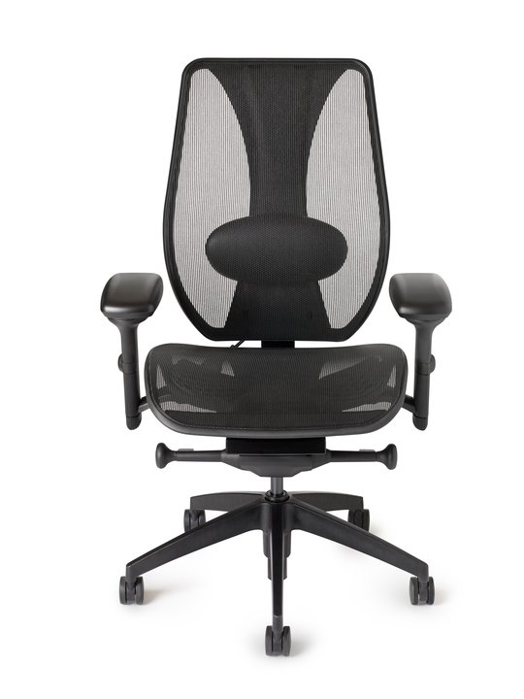  - Adjustable Headrest [AHRTSG]

