High Wipe Down Bench Stool
[HI-WDBS]
Frame  - 14 Gauge, 7/8" Steel Tube Frame  - Height (Polyurethane Seat Options) 31"  - Chrome footring provides additional leg support (height) 12"  - Non-slip and non-making glides (black) work with all floor surfaces | Additional Options  - ergoCentric+Guard Sealed Seat (includes under seat pan) [EGUSS]  - Cal. 133 [Cal133]  - Anti Static (Available in fabric and vinyl only) [ANTISTATIC]  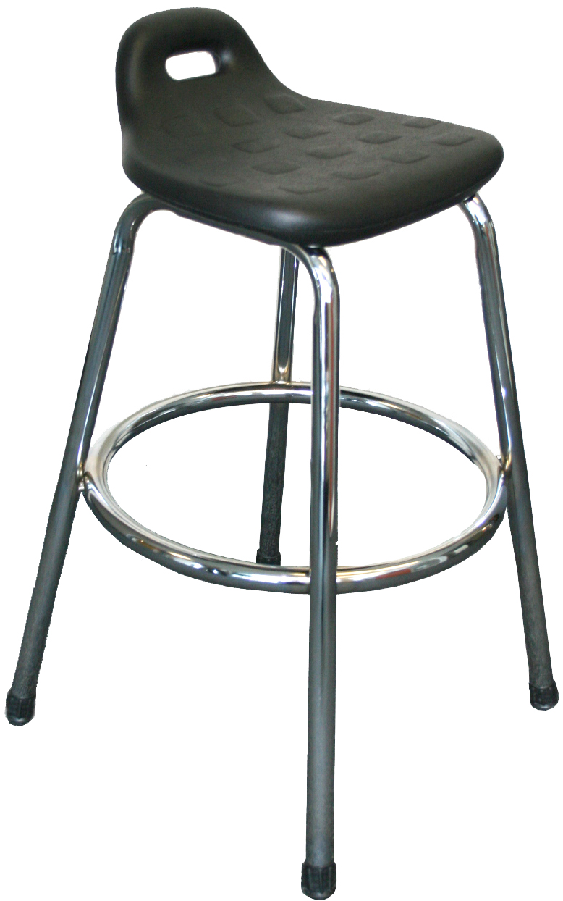  - Class 100 Cleanroom (only available in vinyl) [CRPACK]

